|  |  |  |  |
| --- | --- | --- | --- |
| **Name:** |  | **Date:** |  |
| **Program:** |  | **Section:** |  |

**Intended Learning Outcomes:**

1. Use PHP scripts to receive, store, and manipulate user data.
2. Utilize PHP forms.

Create a form that has four input fields named Word1, Word2, Word3, and Word4 as well as “Reset” and “Submit” buttons. Create a form processing script that verifies that all four words are entered, that all of them contain only letters, and that all four words are between 4 and 7 characters long. Once all of the words have been verified as correct, use the strtoupper() and str_shuffle() functions to produce four jumbled sets of letters.

The form must also have a distinct layout using HTML and CSS. You may opt to use a Bootstrap theme, but this is optional.

Here is a sample output:

**The Form:**

**APPLE BANANA CHERRY DURIAN**

**The Error Message:**

**The Output:**

Hint: Create functions that will display the error and validate the inputs of the user.

================================================================================

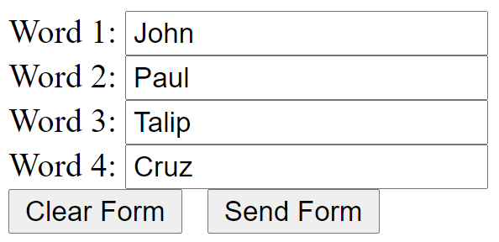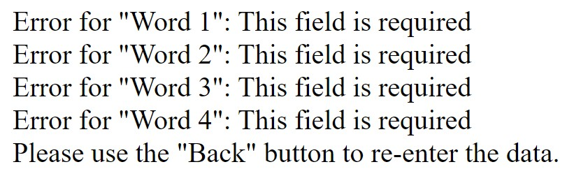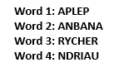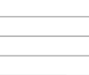

**HTML with PHP Source Code:**

Use Courier New 9 as the font face and size.

Format the paragraph spacing to 0pt before and after and use single spacing. Ensure proper formatting of your source code.

Add breaks or new lines in the codes if necessary.

**CSS Source Code:**

Use Courier New 9 as the font face and size.

Format the paragraph spacing to 0pt before and after and use single spacing. Ensure proper formatting of your source code.

Add breaks or new lines in the codes if necessary.

**Output**

Screenshot of your output from a Browser.

Provide the screenshot of the entire webpage in this area. Attach the full-size screenshot in the submission bin as well.

**Findings and Observations:**